Abstract

**Optimizing Resources to Address STEM Gender Disparities in Western China**

**Xiang (Oscar) Wan**

**Nanjing Foreign Language School, China**

This research elucidates gender inequality in STEM fields in western China, leveraging extensive data from the China Education Panel Survey (CEPS) encompassing 20,000 students from 112 schools. It explores disparities in educational outcomes and aspirations in STEM, framed by gender and economic backgrounds. The study employs a muti-objective optimization model to categorize schools by location and rank and an iterative resource allocation process to propose an equitable resource allocation method to mitigate gender gaps. By focusing on optimizing resource distribution to address disparities, this study contributes to fostering a diverse and inclusive STEM environment, offering insights for policy improvements and interventions aimed at promoting gender and economic equity in education in China.-- Title: Optimizing Resources to Address STEM Gender Disparities in Western China --

1. **Introduction**

Gender inequality in STEM (Science, Technology, Engineering, Mathematics) fields in western China is a significant issue with far-reaching implications, requiring thorough exploration and intervention. Gender stereotypes, biased self-assessments, and aspiration gaps between genders in STEM fields, as delineated by Liu (2018), underscore the pervasive and systemic nature of this inequality. Additionally, the observed inequality of opportunity in educational outcomes in China, highlighted by Golley and Kong (2018), contributes to the existing disparity and consequently affects the participation of women in STEM fields. Specially, for China, a country with significant west-east resource imbalance, the gender inequality in STEM in western China is an important issue to solve. The importance of addressing these inequalities cannot be overstated as STEM fields are fundamental in driving the prosperity and development of nations, companies, and individuals (Podobnik et al., 2020). Addressing these inequalities is crucial to fostering a diverse, inclusive, and innovative STEM environment in China.

Some individuals may contend that inherent ability differences between the genders underlie this disparity. Yet, even when controlling for potential aptitude discrepancies, a profound gap remains between male and female representation in these fields (Riegle-Crumb, King, Grodsky, & Muller, 2012). A plethora of scholarly literature underscores the pervasive role of sexism and entrenched gender stereotypes as the predominant drivers of this gender chasm (Miller, Eagly, & Linn, 2015; Ceci, Ginther, Kahn, & Williams, 2014).

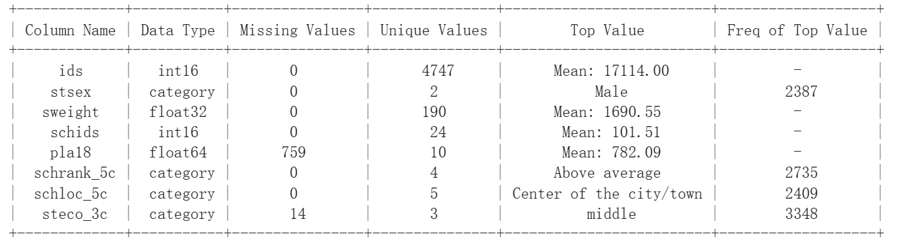Throughout the numerous endeavors to mitigate this gender disparity, a significant body of research emphasizes the pivotal role of educational initiatives and targeted interventions during middle school. These interventions aim to galvanize female students to pursue STEM-related disciplines at tertiary institutions (García-Holgado et al., 2020). Few literatures have proposed an optimization design to for optimal resource distribution to solve gender inequality in STEM education in western China. this paper investigates into the optimal allocation of resources in western China to try to shed light on possible policy improvement to maintain equity in western China.

1. **Data and Methods**

**2.1. Data Source**

To unravel the intricate tapestry of gender inequalities in STEM fields in western China, this research harnesses the extensive and meticulous data provided by the China Education Panel Survey (CEPS). CEPS is a longitudinal survey that embarks on a comprehensive exploration of educational processes and transitions, offering an unparalleled glimpse into the multifarious contexts of educational outcomes in China, including familial influences, community environments, and social structures.

This robust data source encapsulates the responses of approximately 20,000 students from 112 schools, providing a diverse array of perspectives, experiences, and insights. The survey embraces a multifaceted approach, incorporating questionnaires administered to students, parents, teachers, and school administrators, and addressing a breadth of topics, ranging from demographic characteristics to perceptions of education and expectations for the future. It meticulously documents students’ progress, achievements, relationships, and interactions, allowing a profound exploration of the variables influencing gender disparities in STEM.

Since I am interested in western China, I take the data frame and selected out students from western China. The tale below is the data description. Since the dataset is a metadata with hundreds of columns storing the result of the survey questions, I cleaned the data by selecting only the variables that are useful for the analysis.

*Table 1 Data Description*

|  |  |  |  |
| --- | --- | --- | --- |
| Column Name | Data Type | Missing Values | Unique Values |
| Ids | int16 | 0 | 4747 |
| Stsex | category | 0 | 2 |
| Sweight | float32 | 0 | 190 |
| Schids | int16 | 0 | 24 |
| Pla18 | float64 | 759 | 10 |
| Schrank_5c | category | 0 | 5 |
| Scholoc_5c | category | 0 | 5 |
| Steco_3c | category | 14 | 3 |

* 1. **Conceptual Framework**
     1. ***Methodology***

Initially, my model categorizes the sampled schools into different levels, focusing on two crucial parameters for each school:

**Location** (e.g., Center, Outskirts, Rural-Urban Fringe Zone, Towns outside, Rural areas of the city/town)

**Rank in the location** (e.g., Among the best, Above Average, Average, Below Average, Near the bottom)

I calculate a hybrid score for each school by combining the two parameters; schools with identical scores are grouped together. For schools at each level, I consider the standardized math score as indicative of STEM education quality within the school. The gender gap within each school is calculated, then summed at each level.

Next, I apply an optimization model for resource allocation, allocating resources to each school type based on gender gap magnitude. The potential effectiveness of a resource unit is determined by two facts:

1. One unit of resource will have more effect on schools with higher gender gaps.  
2. The effectiveness of resources decreases as more units are allocated, indicative of diminishing marginal return.

I used the iterative resource allocation method to allocate resources. Subsequently, after categorizing schools into different levels, the gender gap of students from different economic backgrounds is calculated at each school level. This aids the model in accounting for gender gap variations across different backgrounds, ensuring equitable resource distribution.

Finally, after I have categorized the schools to different levels, for each school level, I also calculated the gender gap of students from different family economic background. This helps the model to account for the gender gap difference for students with different background and makes the resource distribution more equitable

To conclude, this methodology combines the calculation of school level, gender gap, and the optimization model to deliver a lucid resource distribution outcome for varying levels of schools in Western China, informing educational budgets for each student type.

* + 1. ***General Assumptions***

1. *Potential Effect of Resource*: This model assumes that resources are more effective where the gender gap is higher and that resources diminish in effectiveness as more are allocated. The model uses logarithm to model this curve.

2.*School Level*: This model assumes a school's level is determined by its location and its rank therein. The school level is calculated by summing the scores of locations and rank using equal weight, and schools with the same score are classified as one level.

3. *STEM Difference*: This model assumes the difference in STEM can be interpreted through the mathematics score difference, viewing it as the representation of the gender gap in STEM education.

4. *Proportional Resource*: This model assumes that the investment for girls’ STEM education is proportional to the total resource the girl receives.

* + 1. ***Optimization Model***

*Part 1: Categorizing school level and calculating gender gap*

The level of each school is determined by its location and its rank in that location.

$$\begin{aligned}S_{hybird}= S_{location}+S_{rank}\#\left(1\right)\end{aligned}$$

$S_{hybird}$ is the*Score* used to determine school level.

$S_{location}$ is the *Location Score*, with schools closer to the city/town center scoring higher. $S_{rank}$ 
 is the *Rank Score*, dependent on the school's rank in the survey data.

Schools are categorized into different levels according to their scores, and then, the gender gap for each school level is calculated using the score difference in mathematics between genders.

$$\begin{aligned}G_{i}=\sum_{j=1}^{n_{i}}{\left(S_{boy,ij}-S_{girls,ij}\right)×N_{girls,ij}}\#\left(2\right)\end{aligned}$$

**Gi** measures the *Total Gender gap for school*from the ith level, which measures the magnitude the gender gap.  
**ni** is the*number of schools*in the ith level. $S_{boy,ij}$  
is the*average math score for boys*from the jth school from the ith level $S_{girls,ij}$ 
is the*average math score for girls*from the jth school from the ith level $N_{girls,ij}$ is the *number of girls* in the jth school from the ith level

The reason we multiplied the number of girls here in the back is because we want the variable to actually reflect the magnitude of the gender gap.

For a truly equitable resource allocation, we also define the gender gap for students from different family economic backgrounds.

Gi, k­ measures the gender gap for student from the family background k (poor middle, rich) in school of level i.

$$\begin{aligned}G_{i,k}=\sum_{j=1}^{n_{i},k}{\left(S_{boy,ijk}-S_{girls,ijk}\right)×N_{girls,ijk}}\#\left(3\right)\end{aligned}$$

*Part 2: Optimizing resource allocation*

***a). Objective:***

Our objective is to maximize the effectiveness of the resources allocated to different school level so that we can reduce gender gap, this defines an important goal as it has the potential to dramatically increase the gender inequality in STEM, thereby creating a more equitable academic environment.  
Potential effectiveness of school type i is defined as:

$$\begin{aligned}P_{i}=\log\left(G_{i}+1\right)-log⁡(R_{i}+1)\#\left(4\right)\end{aligned}$$

In this equation:   
**Pi** is the *Potential Effectiveness of resource of school*from the ith level.  
**ni** is the*number of schools* in the ith level.   
**Ri** is the*resource already allocated to*school from the ith level

This equation reflects two pieces of information:  
1. The higher the gender gap for one school level, the higher the potential effectiveness for each additional resource

1. The more resources allocated to one school level, the less the potential effectiveness.

**Accordingly, this is the Objective function:**

$$\begin{aligned}min⁡(maxP_{i}-minP_{o})\#\left(5\right)\end{aligned}$$

We used this potential effectiveness function and the objective function to prioritize our resources on the gender gap in each school level.

***b) Decision Variable:***

$R_{i,k}$: Money allocated to student from family background k in school level i.

***c) Constraints***

1. Total Resource Constraint:

The sum of all money allocated to all school levels cannot exceed the total available resources.

$$\begin{aligned}\sum_{i}{\sum_{k}{R_{i,k}≤R_{total}}}\#\left(6\right)\end{aligned}$$

1. Non-negativity Constraint:

The resources to students from all backgrounds and school levels should not be negative.

$$\begin{aligned}R_{i,k}≥0 ∀i,k\#\left(7\right)\end{aligned}$$

1. Student Background Constraints:

The total resources allocated to students from all backgrounds within one school level should equal to the total school level

$$\begin{aligned}\sum_{i}{R_{i,k}=R_{k}}\#\left(8\right)\end{aligned}$$

1. Student Background Equity Constraint:

For each background (poor middle rich):

$$\begin{aligned}{α }_{i,k} =\frac{G_{i,k}}{G_{i}}\#\left(9\right)\end{aligned}$$

$$\begin{aligned}R_{i,k}={α }_{i,k} R_{k}\#\left(10\right)\end{aligned}$$

${α }_{i,k}$ is an adjustment factor to prioritize or ensure more resources for a particular background with high gender inequality in STEM. This constraint will ensure that resources are allocated effectively by addressing gender gaps for students from each background instead of merely the number of people, allowing for a more equitable distribution and focusing on the needs of individuals.

1. **Results**
   1. **School Levels, Economic Backgrounds, and Gender gap**

I utilized location and rank data to calculate the scores for all sampled schools in Western China, subsequently classifying these schools into different levels based on their scores. Table 1 presents the percentage of schools at each level.

*Table 2 Number of schools in each level*

|  |  |  |
| --- | --- | --- |
|  | Counts | Percentage |
| Level 1 | 5 | 20.83% |
| Level 2 | 3 | 12.5% |
| Level 3 | 2 | 8.33% |
| Level 4 | 2 | 8.33% |
| Level 5 | 8 | 33.33% |
| Level 6 | 4 | 16.67% |

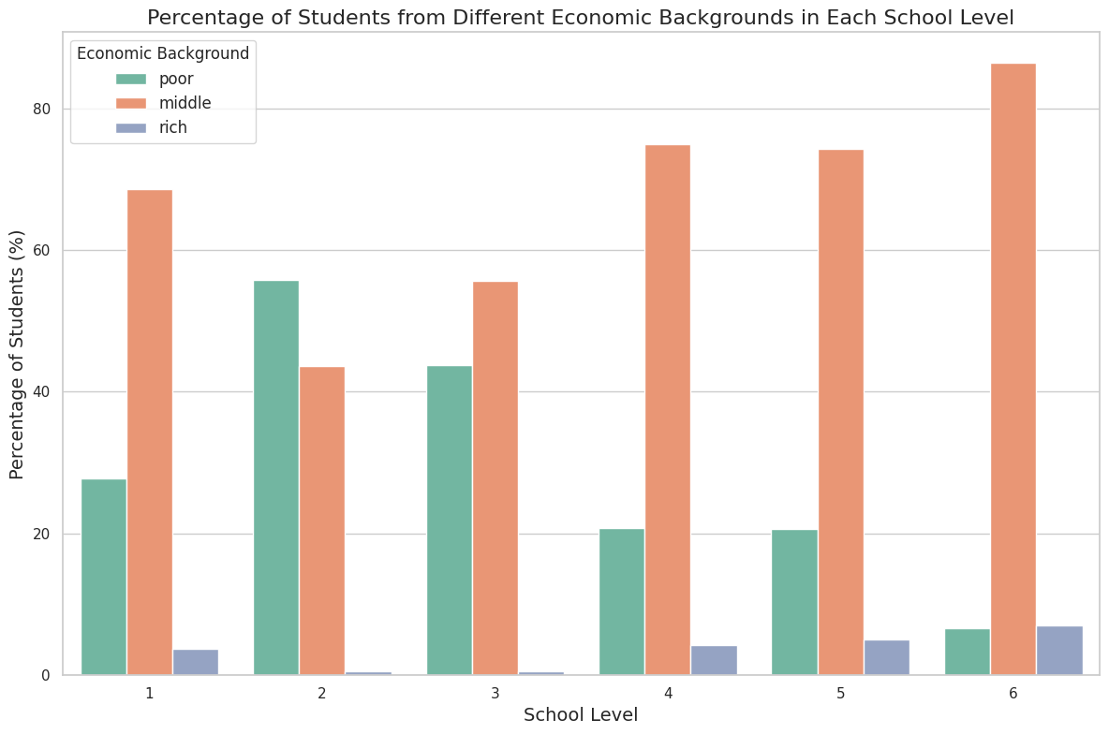Within each school level, the composition of students from different economic backgrounds varies. Therefore, I have plotted the composition of students from each economic background across the six identified levels.

*Figure 1 Students from Different Economic Background in Each School Level*

This figure clearly illustrates the varied student composition in different schools. Generally speaking, schools of a higher level tend to have wealthier students. It’s also plausible that the gender gap varies among students from different economic backgrounds. Consequently, our research design, which assigns resources within a school level based on the gender gap for each economic background—rather than the number from each economic background—is logical and ensures equality.

By employing the formula proposed, I can determine the gender gap at each school level.

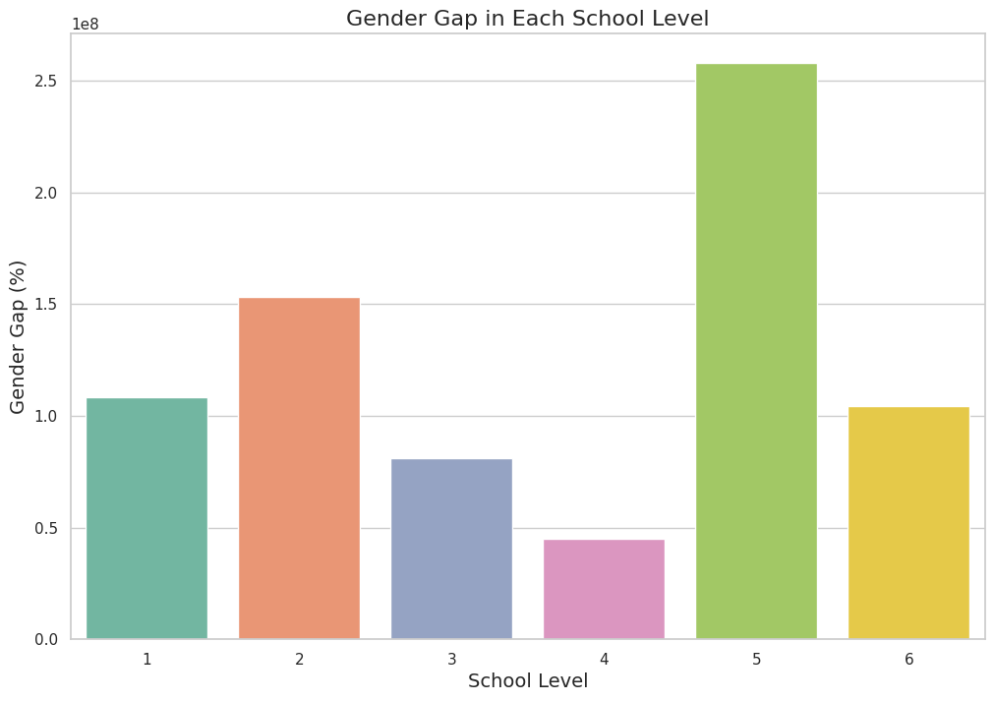

*Figure 2 Gender Gap in STEM*

This bar chart shows the magnitude of gender gap from each school level. With the calculated information on the gender gap available, I proceed to optimize resource allocation.

**3.2. Optimizing resource allocation to solve gender inequality in STEM education**

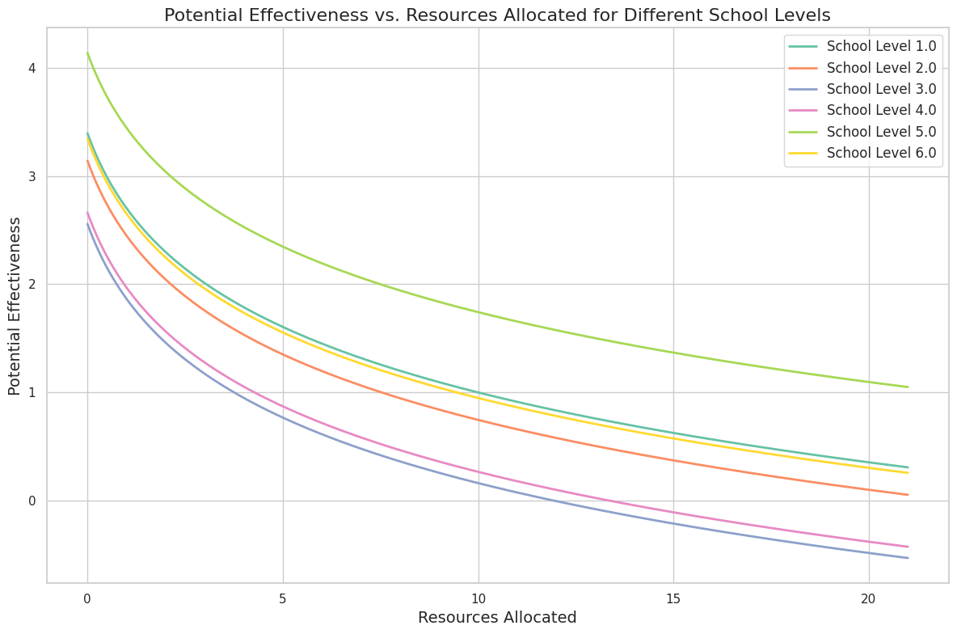 To optimize resource allocation, I initially plotted the potential effectiveness curve for each school level. This curve adheres to two rules: a higher gender gap and fewer resources at the school level correlate to greater potential effectiveness.

*Figure 3 Potential Effectiveness Curves*

I have chosen to employ iterative resource allocation to maximize the potential effectiveness of the resources. That is, for each additional resource unit, I calculate the effectiveness at all school levels and then allocate it to the school exhibiting the highest potential effectiveness. Below is the allocation process:

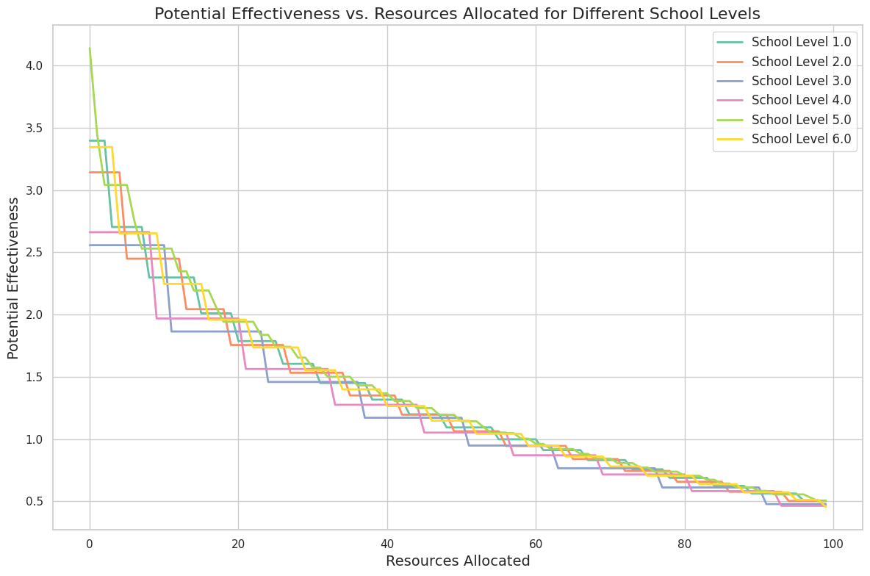*Figure 4 The Iterative Resource Allocation Process*

After completing the resource allocation process, I determine the percentage of our resources that should be allocated to each school level. The table below presents the results of the allocation.

*Table 3 Resources Allocated to Schools in Each Level*

|  |  |  |  |  |
| --- | --- | --- | --- | --- |
|  | Weighted Gender Gap | Percentage | Resources Allocated | Final Potential Effectiveness |
| Level 1 | 17.5% | 20.83% | 18% | 0.50 |
| Level 2 | 13.4% | 12.5% | 12% | 0.50 |
| Level 3 | 7.2% | 8.33% | 7% | 0.48 |
| Level 4 | 8.1% | 8.33% | 8% | 0.47 |
| Level 5 | 37.4% | 33.33% | 37% | 0.50 |
| Level 6 | 16.5% | 16.67% | 17% | 0.46 |

From this table, it’s evident that the resources allocated to each school level are generally proportional to their number, suggesting a pervasive similarity in levels of gender inequality in STEM across schools in Western China, irrespective of the school’s level. This implies that optimal resource allocation tends toward an equal distribution, with modifications influenced by the optimizing model.

When comparing this optimized result with the actual resource allocations for girls—calculated using “average money spent on each student” data from the survey—noticeable differences emerge.

*Table 4 Optimized and Actual Resource Allocation*

|  |  |  |  |
| --- | --- | --- | --- |
|  | Optimized Resources | Actual Resource | Difference |
| Level 1 | 18% | 16% | 2% |
| Level 2 | 12% | 32% | 20% |
| Level 3 | 7% | 12% | 5% |
| Level 4 | 8% | 7% | 1% |
| Level 5 | 37% | 19% | 18% |
| Level 6 | 17% | 12% | 5% |

Surprisingly, schools at higher levels are receiving less than what is optimized. This could imply that the country may be allocating more resources to lower-level schools to elevate the educational standard. However, as modeled, the gender gap in STEM education appears consistent across all school levels in Western China, suggesting that this factor may be overlooked during the actual resource allocation process by decision-makers.

Considering this factor, it is plausible that the current resource allocation structure could undergo modifications to be optimized, thereby addressing the pervasive gender gap in STEM. Neglecting the widespread gender gap could potentially impact China’s academic landscape.

**3.3 Optimizing for students from different economic background**

Once we understand the resource distribution structure for different school levels, it doesn’t differentiate between students from various backgrounds. Segmenting students by economic background can address these issues. The subsequent graph illustrates the composition of the gender gap at each school level.

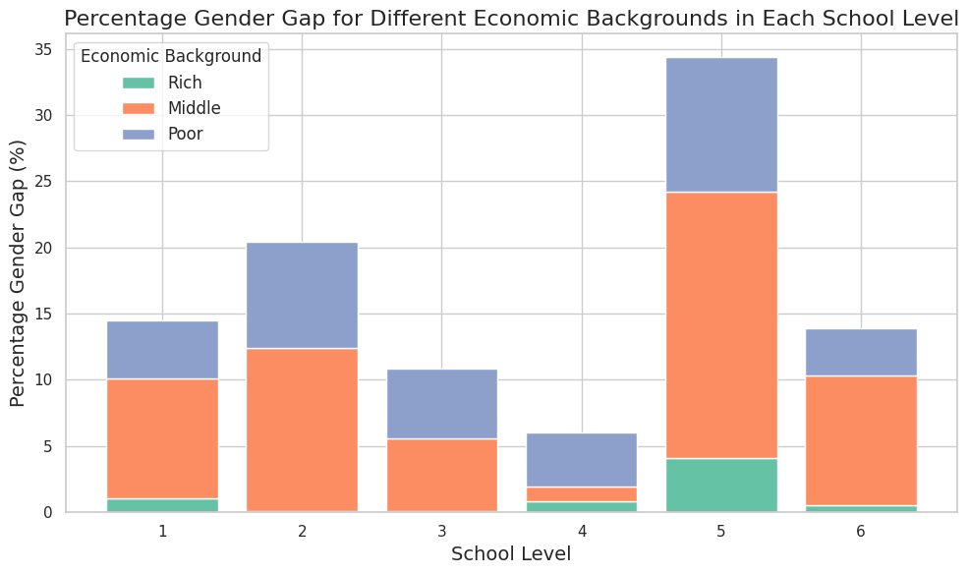*Figure 5 The Gender Gap in STEM for different Economic Backgrounds*

The graph portrays the composition of the gender gap. By representing the gender gap makeup at different school levels and segregating them by economic backgrounds—rich, middle, and poor—we can calculate a weight for each economic background within each school level.

*Table 5 Weight for each economic background*

|  |  |  |
| --- | --- | --- |
|  | Economic Background | Weight (%) |
| Level 1 | Poor | 30.138878 |
| Middle | 62.660503 |
| Rich | 7.200622 |
| Level 2 | Poor | 39.154240 |
| Middle | 60.302525 |
| Rich | 0.543231 |
| Level 3 | Poor | 48.249210 |
| Middle | 51.031883 |
| Rich | 0.718905 |
| Level 4 | Poor | 66.990501 |
| Middle | 18.525965 |
| Rich | 14.483536 |
| Level 5 | Poor | 29.564947 |
| Middle | 58.545799 |
| Rich | 11.889258 |
| Level 6 | Poor | 25.415390 |
| Middle | 70.792587 |
| Rich | 3.792028 |

Given this information, it is advisable for the government to consider the gender gap among different student types when allocating resources to each school level. It would be optimal if the government could provide guidelines, enabling local decision-makers and schools to understand precisely how much should be allocated to students from each background.

**4. Discussion**

The outcomes of this study are imperative in presenting a nuanced understanding of the disparities inherent in the allocation of educational resources, with a focal emphasis on gender inequalities in STEM within schools in Western China. The model's results illustrate the pervasive gender gap in STEM across various school levels and economic backgrounds, revealing that the disparity is not isolated to a specific demographic or school level but is a widespread issue.

The significance of these findings lies in their capacity to inform educational policy and resource allocation decisions that impact gender equality in STEM education. By acknowledging the varying compositions of economic backgrounds within each school level and recognizing the nuances in the gender gap, policymakers can tailor interventions to be more equitable and effective.

However, it can also be argued that my model is not applicable to real world scenarios because some of my assumptions might not hold true. Nevertheless, there are justifications these assumptions in this study.

**Assumption 1 Potential Effectiveness:** This assumption was crucial to quantify the impact of resources in reducing the gender gap, which is essential for the development of an optimal resource allocation model. It may oversimplify the multifaceted nature of resource effectiveness. The actual impact may depend on various contextual factors like the quality of implementation and the receptivity of the students and the school. But according to the demising marginal utility curve, we can say this curve is generally true

**Assumption 3 STEM Difference via Math Score**: The survey data only have Chinese, English, and Mathematic scores of the students. Relying solely on math scores may not encompass the entirety of skills and knowledge that constitute STEM proficiency. But Math scores are often indicative of a student’s capability in logical reasoning and problem-solving, which are crucial components of STEM education.

**Assumption 4 Proportional Resource:** This assumption does not account for the differing resource needs of individual students. It provides a methodological simplification to model the resource allocation effectively and ensures the result is comparable to the actual resource allocation

For a more comprehensive approach, future research should consider incorporating additional parameters such as teaching quality and the variability in students’ learning needs and preferences. Moreover, exploring the effectiveness of different types of resources and interventions in addressing gender gaps in STEM would be beneficial.

Additionally, a participatory approach involving educators, students, and policymakers in the decision-making process can help in the contextual implementation of the resource allocation strategies. This inclusive approach would ensure the consideration of diverse perspectives and needs, enabling the development of more robust and equitable educational strategies.

1. **Conclusion**

The major implication of this study for the study is straightforward: Current resource allocation system might have overlooked the wide-spread gender inequality in western China. The revelations from this study underscore the need for revisiting and reformulating educational resource allocation strategies to address the nuanced disparities in STEM education in Western China.

What’s more the proposed model and findings pave the way for more equitable and informed resource allocation, aiming to bridge the gender gap across different school levels and economic backgrounds. Embracing a holistic and inclusive approach, considering various stakeholders’ insights and addressing the limitations of the current model, will be crucial in advancing gender equality in STEM education and fostering an environment where every student has the opportunity to excel.

1. **References**

Liu, R. (2018). Gender-math stereotype, biased self-assessment, and aspiration in STEM careers: The gender gap among early adolescents in China. *Comparative Education Review, 62*(4), 522-541.

Golley, J., & Kong, S. T. (2018). Inequality of opportunity in China's educational outcomes. *China Economic Review, 51*, 116-128.

Podobnik, B., Crawford, G. C., Lichtenstein, B., Lipic, T., Wild, D., Zhang, X., & Stanley, H. E. (2020). The new wealth of nations: How STEM fields generate the prosperity and inequality of individuals, companies, and countries. *Chaos, Solitons & Fractals, 141*, 110323.

Li, J., Feldman, M. W., Li, S., & Daily, G. C. (2011). Rural household income and inequality under the Sloping Land Conversion Program in western China. *Proceedings of the National Academy of Sciences, 108*(19), 7721-7726.

Li, X., Shenggen, F. A. N., Xiaopeng, L. U. O., & Zhang, X. (2009). Community poverty and inequality in western China: A tale of three villages in Guizhou Province. *China Economic Review, 20*(2), 338-349.

Blackburn, H. (2017). The Status of Women in STEM in Higher Education: A Review of the Literature 2007–2017. Science & Technology Libraries, 36(3), 235–273. https://doi.org/10.1080/0194262X.2017.1371658

Casad, B. J., Franks, J. E., Garasky, C. E., Kittleman, M. M., Roesler, A. C., Hall, D. Y., & Petzel, Z. W. (2021). Gender inequality in academia: Problems and solutions for women faculty in STEM. Journal of Neuroscience Research, 99(1), 13–23. https://doi.org/10.1002/jnr.24631

Ceci, S. J., Ginther, D. K., Kahn, S., & Williams, W. M. (2014). Women in Academic Science: A Changing Landscape. Psychological Science in the Public Interest, 15(3), 75–141. https://doi.org/10.1177/1529100614541236

García-Holgado, A., Verdugo-Castro, S., González, C., Sánchez-Gómez, M. C., & García-Peñalvo, F. J. (2020). European Proposals to Work in the Gender Gap in STEM: A Systematic Analysis. IEEE Revista Iberoamericana de Tecnologias Del Aprendizaje, 15(3), 215–224. https://doi.org/10.1109/RITA.2020.3008138

Miller, D. I., Eagly, A. H., & Linn, M. C. (2015). Women’s representation in science predicts national gender-science stereotypes: Evidence from 66 nations. Journal of Educational Psychology, 107(3), 631–644. https://doi.org/10.1037/edu0000005

Riegle-Crumb, C., King, B., Grodsky, E., & Muller, C. (2012). The More Things Change, the More They Stay the Same? Prior Achievement Fails to Explain Gender Inequality in Entry Into STEM College Majors Over Time. American Educational Research Journal, 49(6), 1048–1073. https://doi.org/10.3102/0002831211435229

White, B. A., Miles, J. R., & Frantell, K. A. (2021). Intergroup dialogue: A justice-centered pedagogy to address gender inequity in STEM. Science Education, 105(2), 232–254. https://doi.org/10.1002/sce.21599

**Acknowledgement**

Gender inequality in education in Western China is a muti-dimensional issue that cannot be solved by any strategies along within a short period of time. It requires cooperation between various government sectors, NGOs, and charity organizations. However, an equitable resource allocation can be very useful in accelerating the process of creating an equitable education environment.

During my time at Stanford Summer Session, I was fortunate to take the DATASCI 154 course where my groupmates Ecem Somyurek, Suhani Jain, Sandhya Gopinath and I proposed an optimization design for resource allocation to solve gender inequality in STEM in America. Inspired by this experience, I looked for datasets that can help me to apply a similar framework specifically to China.

The dataset China Education Panel Survey (CEPS) allowed me to apply statistics tool and the optimization model to conduct this research. Considering the special circumstances and the features of the dataset, I categorized schools to different levels using their location and rank data. I allocated resource accordingly to the gender gap in Mathematics in each school type. I also considered students from different social economic background.

Here, I would like to show my gratitude for my groupmates. It is our efforts together that inspired me to write this research paper. I would also like to thank my Stanford tutor, Doctor Mallory Nobles, without whose support I wouldn’t have constructed such an optimization model. I would also thank the scholars that have done the China Education Survey, it is their endeavor that makes a quantitative analysis in resource allocation possible.